Official league roster - Basketball
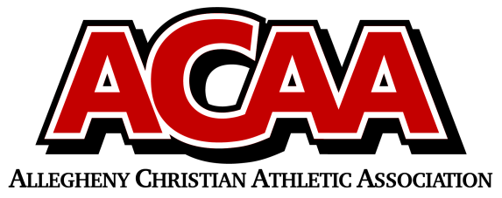

Columbia County Christian
Team Colors:
Overall Wins ___ Losses ____ Ties ___
ACAA Wins ___ Losses ____ Ties ___ OPPONENT: __________________________
Date: _________
Number | Name | Year | Homeschool
2 | Olivia Beishline | 12
22 | Ashleigh Boudman | 11
1 | Willa DuMond | 11
10 | Elizabeth Yocum | 11
14 | Audrey Mood | 10
15 | Maycie Davis | 10
12 | Lilly DuMond | 9
4 | Emma Farley | 9
3 | Isabella Farley | 9
 | Ava Moskovich | 7

Head Coach: Kelli Boudman
Asst. coach: torre boudman

Official ACAA League Team Roster. to be submitted to the scorer’s table before each game.

